R ASSIGNMENT: RESEARCH METHODS IN FOREST SCIENCES

|  |  |
| --- | --- |
| **Group Members** | **Student No.** |
| Amaitum Joshua Elukut | 2216274 |
| Uche Ndudi Omeoga | 330344 |

School of Forest Sciences

University of Eastern Finland

**INTRODUCTION**

This report is about a task that followed lectures on use of R during the Research Methods in Forest Sciences Course. R is a use tool for analyzing data because of its statistical computing power and graphics development potential which supports data visualization.

For this exercise we were given data for a particular stand with variables like diameter, height, age, and basal area. We were then tasked to describe the data mathematically and visually represent some relationships. Furthermore, the task entailed developing a model to for estimating the total stem volume in the stand. This model was a function of basic stand characteristics. Thereafter, we would test the suitability of the model, firstly by comparing its performance against data from which it was developed (modelling dataset), and secondly against data from an entirely new forest stand (validation dataset) with the aim of judging its judge its precision, accuracy, and overall performance

**Objectives**

* To determine the descriptive characteristics of the stand characteristics such as mean, minimum, maximum, and standard deviation.
* To make visual representations of some attributes/variables of the data such as the total volume.
* To create linear regression models for estimating total stem volume in the stand (m3 ha-1) as a function of basic stand characteristics (e.g. diameter, height, possibly other variables).
* To select the most ideal model and determine its suitability for predicting volume using values from two datasets.
* Bias and RMSE values in validation data set.

**Note:** Group4 dataset was used as the modelling data set

**MATERIALS**

**Modelling dataset**

**Summary statistics of modelling dataset**

|  |  |  |  |  |  |  |
| --- | --- | --- | --- | --- | --- | --- |
|  | **AGE** | **P0** | **BA** | **D** | **H** | **TOTAL_VOLUME** |
| **Min** | 21.00 | 707.9 | 1.465 | 5.808 | 5.329 | 6.463 |
| **Max** | 256.00 | 1360.3 | 48.993 | 33.236 | 25.049 | 508.432 |
| **Mean** | 69.95 | 1046.8 | 21.641 | 17.063 | 12.403 | 144.928 |
| **Sd** | 43.42 | 135.2 | 9.962 | 5.986 | 3.990 | 94.776 |

Number of plots = 150

**Scatter plots of total volume and other variables in modelling data set**

**Validation dataset**

**Summary statistics of validation dataset**

|  |  |  |  |  |  |  |
| --- | --- | --- | --- | --- | --- | --- |
|  | **AGE** | **P0** | **BA** | **D** | **H** | **VOLUME** |
| **Min** | 11.00 | 708.5 | 1.191 | 5.813 | 5.314 | 5.691 |
| **Max** | 337.00 | 1405.4 | 51.442 | 39.994 | 28.509 | 560.238 |
| **Mean** | 67.57 | 1045.4 | 21.567 | 17.191 | 12.638 | 143.360 |
| **Sd** | 43.94 | 133.77 | 10.217 | 6.028 | 3.939 | 92.111 |

**Number of plots =** 1000

**METHODS**

The steps below were followed

* First step was to start with a model that included all the ratio scale variables since they are the suitable ones.
* The summary of that model revealed that only 3 independent variables (BA, H, D, & SP_GROUP) were significant.
* We dropped the non-significant variables and saved only 3 variables in a new object.
* We run a correlation analysis between the dependent variable and the three independent variables to determine its extent, to guide my selection of variables for the next model.
* The results indicated that TOTAL VOLUME had the specified correlations with the three different variables: BA= 0.920752, H= 0.77428475, D= 0.73508882.
* Thereafter we began to trial different models with varying independent variables, their combinations, and transformations.
* In total about 20 different models were tried before arriving at the final 3. In each case, for each model, the R2, p-value, plot of residuals and fitted values, together with the histogram of residuals were examined to arrive at the final shortlist. The suitable models had good attributes for the previously highlighted parameters.
* The chosen model was used to predict new volumes in the modelling dataset and these were compared to the reference volumes previously obtained to assess how good the model was.
* Similarly, the selected model was then used to predict volumes for a the validation dataset which was from a new area and contained even more plots (in this case 1000 compared to 150) previously obtained.
* The newly modeled volume was then also compared with the reference volume in the validation dataset.
* Furthermore, the RMSE and Bias were determined to find out the accuracy and precision of the newly created model.
* **RMSE Equation:** sqrt(mean((obs.pred1$Modeled - obs.pred1$Original)^2))
* **BIAS Equation:** t.test(obs.pred1$Original,obs.pred1$Modeled,paired=TRUE)

**RESULTS**

**Modelling results**

**The best 3 models**

First model: TOTAL_VOLUME = 100.351256 + 0.938934*log(BA*H)

Second model: TOTAL_VOLUME = 10-0.344490 + 0.891245*log(BA*D)

Third model: TOTAL_VOLUME = (1.079893 + 0.551283*√ (BA*D))2

**Model Summary**

|  |  |  |  |  |
| --- | --- | --- | --- | --- |
| **Model** | **R** | **R-Square** | **Adjusted R Square** | **Std. Error of the estimate** |
| 1 | 0.9973 | 0.9947 | 0.9947 | 0.05096 |
| 2 |  | 0.9829 | 0.9827 | 0.09165 |
| 3 |  | 0.9847 | 0.9846 | 0.4661 |

**Coefficients**

|  |  |  |  |  |  |
| --- | --- | --- | --- | --- | --- |
| **Model** | | **Unstandardized Coefficients** | | **t** | **Sig.** |
| **B** | **Std. Error** |
| 1 | (Constant) | -0.351256 | 0.030953 | -11.35 | .000 |
| log(BA*H) | 0.938934 | 0.005633 | 166.68 | .000 |
| 2 | (Constant) | -0.344490 | 0.055927 | -6.16 | .000 |
| log(BA*D) | 0.891245 | 0.009675 | 92.12 | .000 |
| 3 | (Constant) | 1.079893 | 0.112773 | 9.576 | .000 |
| √ (BA*D) | 0.551283 | 0.005648 | 97.609 | .000 |

**Note:** Figures, where your independent variables are plotted against the dependent variable have been shared in the MATERIALS section of the report.

Figures showing the model residuals

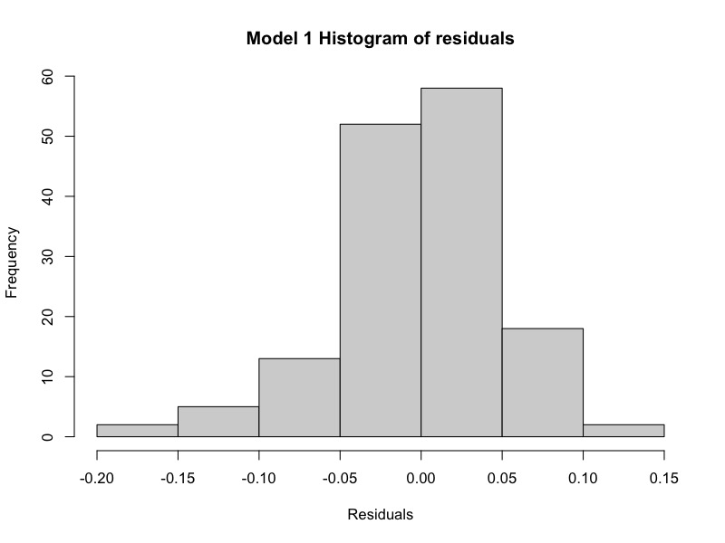

Model 3 is selected as the best model and used in the next stages of the report

**TOTAL_VOLUME = (1.079893 + 0.551283*√ (BA*D))2**

**Validation results**

**RMSE:** 3.371825

**BIAS:** t = 1.312, df = 999, p-value = 0.1898, Since p-value is not less than 0.05, we conclude the bias is not significant

**DISCUSSION**